- BUSINESS
- November 28, 2012, 6:55 p.m. ET

In Sweden, Playtime Goes Gender-Neutral For Holidays

By ANNA MOLIN

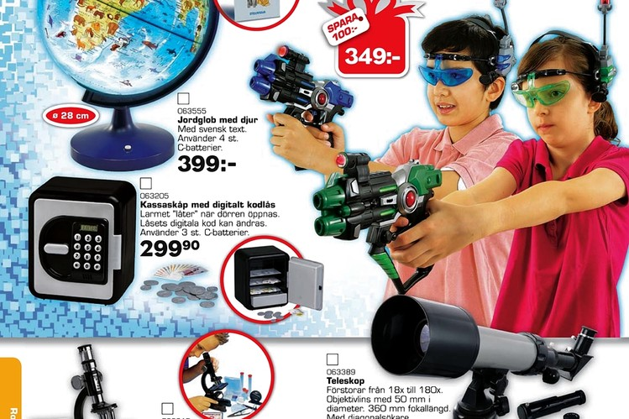
Toys "R" Us
Top-Toy Group's Toys "R" Us catalog in Sweden shows a boy and a girl at play with toy weapons.
This holiday season, how about a toy gun for the girl on your shopping list, and a doll for the boy?
That vision of gender-neutrality in toy-buying is coming to life in Sweden, where Top-Toy Group, a licensee of the Toys "R" Us brand, has published a gender-blind catalog for the Christmas season.
On some pages, girls brandish toy guns and boys wield blow-dryers and cuddle dolls. Top-Toy, a privately-held company, published 12 million catalogs and owns the BR Toys chain, with 303 stores in Northern Europe.
Sweden's top advertising watchdog—known as Reklamombudsmannen, or RO—has taken the retailer to task in recent years for catalogs and ads that showcase girls playing with dolls, scrapbooks, and kitchen and beauty toys and boys with guns, cars, trains and tech gadgets. RO also has criticized Hennes & Mauritz AB, owner of the H&M chain, for ads with bikini models who were too tan.
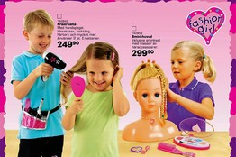
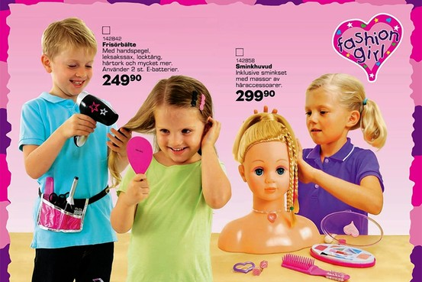
Top-Toy Group
In a Top-Toy Group catalog in Sweden, left, a boy plays with 'Fashion Girl' beauty products.
A comparison of Top-Toy's Swedish catalogs with their Danish counterparts shows girls have replaced boys in some photos featuring toy guns, and boys have swapped places with girls in photos featuring dolls and stuffed dogs. In one picture in the Swedish catalog, a boy is blow-drying a girl's hair whereas in the Danish version, a somewhat older girl is blow-drying her own hair.
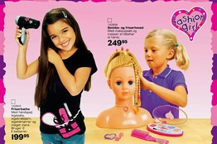
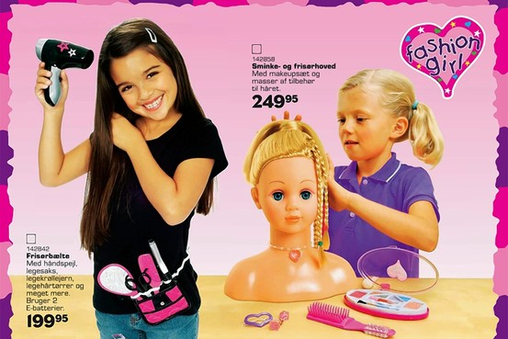
The Toy Group
In a company catalog in Denmark, only girls are shown playing with these toys.
Top-Toy also is working on adjusting store displays and packaging to reflect the gender-neutral approach, said Jan Nyberg, Top-Toy's sales director in Sweden. Boys and girls can now be seen playing together on boxes of "Happy House," Top-Toy's own kitchen set.
"We can't decide what the big toy makers' boxes should look like as their products are made for the global market, but we can make changes on our own boxes and in our stores," Mr. Nyberg said.
The Swedish government has been on the front line of efforts to engineer equality between men and women, with generous paternity benefits and plans to spend the equivalent of some $340 million through 2014 on boosting gender equality in the workplace. Last year, the country famously mulled the use of a single-gender pronoun, "hen," to replace "he" or "she" when a person's gender is unknown or insignificant.
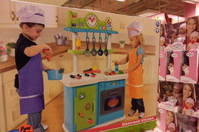
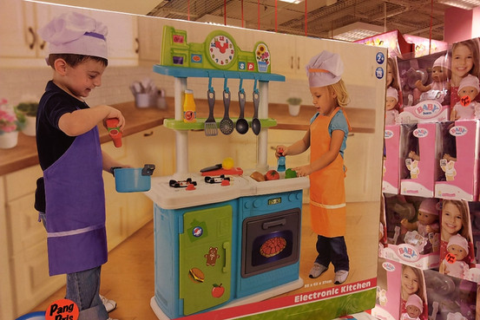
Anna Molin/The Wall Street Journal
At a Stockholm Top-Toy store, a boxed 'Happy House' play set features boys and girls.
In a country of 9 million people, gender equality is seen as a bedrock principle of a productive workforce and a healthy welfare state. Sweden needs women in the labor force to maintain output. State-funded child care structures put in place after World War II have enabled women to return to work after having children, and four different government entities are devoted to the issue.
Mr. Nyberg said the changes reflect cultural trends. "We want our catalog to reflect how kids are playing today," he said. "It's important for us to be modern."
At a BR store in Stockholm Tuesday, images of boys dominated the toy guns and cars section, although images could be found of boys with fluffy pets or playing house.
A saleswoman said she hasn't seen much difference in store displays but noted employees now are trained to avoid stereotypes when talking to customers. "If someone asks for a present for a 5-year-old girl, we don't automatically take them to the dolls section," she said. "Instead, we ask them what her interests are."
Malin Welin, an insurance saleswoman shopping for Christmas gifts with a 2-year-old son, said she was impressed. "I think it's amazing that they've actually listened to the consumers," she said. "I didn't used to shop here as much before they changed, because I didn't like the way they separated between girls and boys, pink and blue."
Other retailers have grappled with this issue. Earlier this year, Harrods, the London department store, opened a shop categorizing toys according to theme, not gender.
The role of gender in childhood development has been a hot topic for decades, especially so in the U.S. after studies in the 1970s asked whether children were being biased toward specific behaviors. By the 1980s and 1990s, many parents took to the idea of buying traditionally-female toys for boys and vice versa.
Lisa Wade, a sociologist and professor at Occidental College in Los Angeles, said Top-Toy's gender-neutral approach is significant because it challenges common ideas about masculinity by putting dolls and hair dryers into the hands of boys. "You may give tool toys to your daughter, [but] you don't give the lipstick bag to your son," she says.
In many cases, she says, she suspects the gender-neutral platform is a marketing ploy. "It's a mistake to think that companies typically do this out of ethical belief," Dr. Wade said. "Most of the time they are doing it strategically."
Elisabeth Trotzig, who serves as the ombudsman for RO, applauds Top-Toy. "I'm convinced others will also follow this line," Ms. Trotzig said. "It's especially important when it comes to children and young people since they don't have the same experience and opportunity to evaluate marketing communication."
Mr. Nyberg says Top-Toy has received positive emails and in-store comments after the change to its catalogs, but not all customers are happy about it. "As always, there are two camps," he says.
Write to Anna Molin at anna.molin@dowjones.com

