8 Studies That Debunk Male Gender Stereotypes
Nature didn't really design men to be especially rational, aggressive, or insensitive. A lot of that has to do with nurture.
Posted on March 6, 2013, at 11:36 a.m.
Kevin Tang
BuzzFeed Staff

You hear conservatives say it all the time: men should 'naturally' be more rational and less sensitive, whereas women's 'natural' brain structures wire them for language and empathy.

Via Twitter: @wutheringhugs

But what if these differences aren't so cut and dry (or even that drastic)? Consider some of these studies:

1. Between infancy and first grade, boys express their emotions more passionately than girls.

Via mii.gamercreated.com
Boys are taught to keep a stiff upper lip, but Harvard med school researchers found thatyoung boys smiled, cried, and laughed more to researchers than girls did. By elementary school, boys become less likely to express sadness or distress, perhaps because of the influence of parenting and culture.

2. Worldwide, boys aren't any better at math than girls.

Via thoughtfulindia.com
Math scores in 86 countries show that K-12 boys don't significantly do better at math than girls, either in general or at elite levels. And the "math gap" in the US has been closing over time. In the 1970s, the ratio of boys to girls with high math cores SATs was 13:1. By the 1990s, it was 3:1.

3. Young men are more emotionally vulnerable to troubles in their relationships than young women are.

Florida State researchers found that men between the ages of 18 and 23 were much more likely be emotionally affected by relationship woes than women. The study authors wrote, "for young men, their romantic partners are often their primary source of intimacy," whereas women feel more encouraged to confide deeply with family and friends. Contrary to what every frat joke tells you, men aren't just naturally detached.

I mean, just listen to Usher here. Or actually, any guy band at all.

4. Men are less rational investors than women.

Via diylol.com
A study of 35,000 households in MIT's Journal of Economics found that men traded stocks with irrational confidence in their judgment. Single men traded less rationally than married men, and married men traded less rationally than single women.

5. Men aren't worse than women at reading emotional cues.
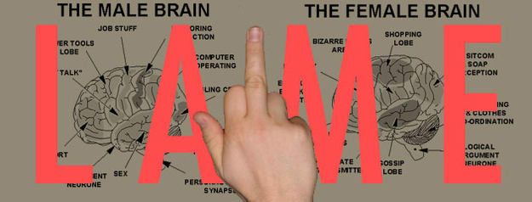

When asked to correctly identify emotions of people in video clips, men were no less capable of reading nuances in emotions than women were. (Interestingly, parents were much better emotional detectives than non-parents.) So men can read moods, but whether they do anything about this emotional information may be a matter of cultural upbringing, which can change.

6. Men monitor their partners more than women.
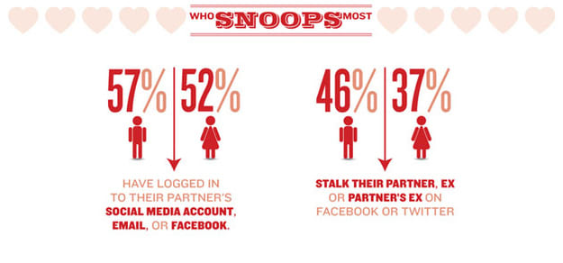

Chris Ritter for BuzzFeed
Women are always been portrayed as jealous, smothering, overly attached girlfriends and wives, but statistics from McAfee show that men are more likely to obsessively check in on their partners online.

7. Men are four times as likely as women to commit suicide after divorce.

Via comicvine.com
The suicide risk for men doubles after divorce, but divorced women aren't more likely to commit suicide than single or married women. The suicide risk of men is already twice as high among men, so that means men are four times as likely to end their lives after the breakup of a marriage.

8. In anonymous settings, men aren't more aggressive than women.

Via geekdashboard.com
Yes, men are encouraged (and praised for) being physically and socially aggressive, but what happens when you remove societal expectations? In one experiment, men and women were told to win a video game by dropping bombs on others. Playing together in the same room, women dropped fewer bombs than men. But when playing anonymously, women dropped more bombs and sought out other players more aggressively than men did.

And finally...

120% of all cosmic surveys show that men and women should just enjoy whatever flavor of Pocky they want. Yes, men still process spatial information faster, and girls still outperform boys in reading comprehension, but 'nature' does not set ideals for behavior – people do.
Flout all the silly rules and binaries. They harm everyone.

